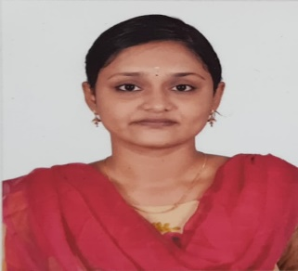Makeswari Sivakumar

[makeswari.sivakumar@mphasis.com](mailto:makeswari.sivakumar@mphasis.com)

9698431339

 Kumbakonam

**Objective**

To obtain a challenging position that fully utilizes my skills and provides me with suitable opportunities to grow my technical and [communication skills](https://leverageedu.com/blog/communication-skills/)which would help me as a fresher to grow while working towards the organizational goals.

 **Education Qualification**

SASTRA DEEMED UNIVERSITY

2022

B. Tech- Computer Science and Engineering

CGPA – 6.98

Christ The King Matric Higher Secondary School

2018

HSC

Percentage – 83.17

Christ The King Matric Higher Secondary School

2016

SSLC

Percentage – 84.60



**Skills**

HTML5 & CSS3

Angular

JAVA

SpringBoot

 **Project**

* PREDICTING AIR QUALITY INDEX IN INDIA [Mini Project]

-The aim of the project is to predict AQI for India

* Parkinson's Disease Detection using Machine Learning Classification Algorithm

-Detect whether a person have parkinson's or not

* Insurance Policy System Management using Angular and Spring Boot

# DECLARATION

I hereby declare that the information furnished above is correct to the best of my knowledge and belief.